I READ A TEXT ABOUT WATER PUMPS IN AFRICA
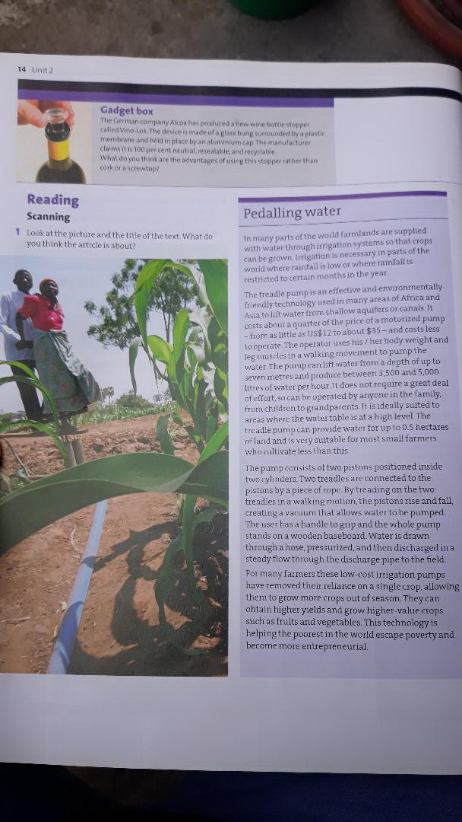
II DO THE FOLLOWING ACTIVITIES RELATED TO THE TEXT
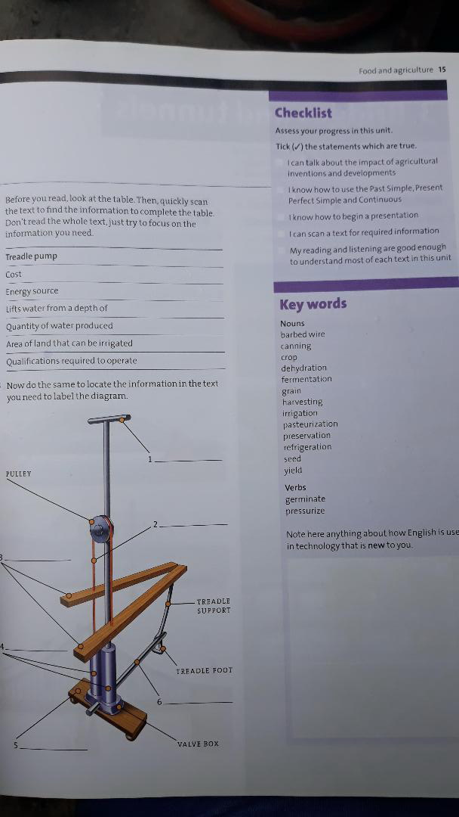
III TRANSLATE ONE PARAGRAPH FROM THE TEXT AND ADD SOME TECHNICAL TERMS TO THE LIST OF KEY WORDS ABOVE
IV WATCH A VIDEO AND TRY TO EXPLAIN HOW A PEDALLING WATER PUMP IS DIFFERENT FORM A PLAYPUMP. https://www.youtube.com/watch?v=qjgcHOWcWGE
V WHAT ARE THE EFFECTS OF A PLAYPUMP ON SOCIETY?
VI WHICH PUMP ARE YOU IN FAVOUR OF AND WHY?

